📊 Little Twins September Sales SQL Queries:
- KPI’s:

- Total Revenue:

SELECT
ROUND(
SUM(Net_Sales),2
)AS Total_Revenue
FROM LittleTwins_September_Sales;

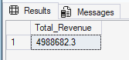

- Total Orders:

SELECT
COUNT(DISTINCT Transaction_ID) AS Total_Orders
FROM LittleTwins_September_Sales;

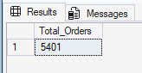

- Average Order Value:
SELECT
ROUND(
SUM(Net_Sales) * 1.0 / COUNT(DISTINCT Transaction_ID),
2) AS Avg_Order_Value
FROM LittleTwins_September_Sales;

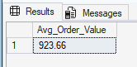

- Unique Customers:

SELECT
COUNT(DISTINCT Customer_ID) AS Unique_Customer
FROM LittleTwins_September_Sales;

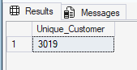

- Discount Rate (%)
SELECT
ROUND(
SUM(Discount_Amount) * 100 / SUM(Gross_Sales)
,2 ) AS Discount_Rate
FROM LittleTwins_September_Sales;

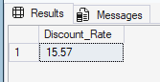

CHARTS REQUIREMENTS:
- Daily Net Sales Trend:
SELECT
CAST(Transaction_Date AS DATE) AS Order_Date,
ROUND(SUM(Net_Sales),0) AS Total_Revenue
FROM LittleTwins_September_Sales
GROUP BY CAST(Transaction_Date AS DATE)
ORDER BY Order_Date ASC;

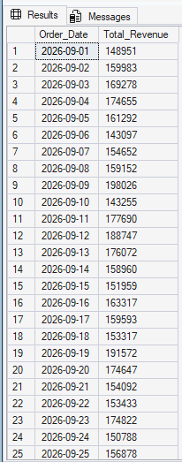
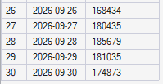

- Net Sales by Category:
SELECT
Category,
ROUND(SUM(Net_Sales),2) AS Total_Revenue
FROM LittleTwins_September_Sales
GROUP BY Category
ORDER BY Total_Revenue DESC;

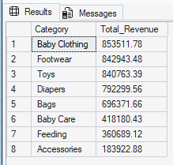

- Top 5 Products:

SELECT TOP 5
Product,
ROUND(SUM(Net_Sales),2) AS Total_Revenue
FROM LittleTwins_September_Sales
GROUP BY Product
ORDER BY Total_Revenue DESC;

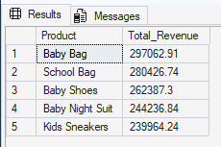

- Net Sales by Customer Location:

SELECT TOP 5
Customer_Location,
ROUND(SUM(Net_Sales),2) AS Total_Revenue
FROM LittleTwins_September_Sales
GROUP BY Customer_Location
ORDER BY Total_Revenue DESC;

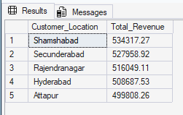

- Discount Effectiveness:

SELECT
CASE
WHEN Discount_Percent = 0 THEN '0% (No Discount)'
WHEN Discount_Percent > 0 AND Discount_Percent <= 10 THEN '1% - 10%'
WHEN Discount_Percent > 10 AND Discount_Percent <= 20 THEN '11% - 20%'
WHEN Discount_Percent > 20 AND Discount_Percent <= 30 THEN '21% - 30%'
WHEN Discount_Percent > 30 AND Discount_Percent <= 40 THEN '31% - 40%'
WHEN Discount_Percent > 40 AND Discount_Percent <= 50 THEN '41% - 50%'
ELSE 'Above 60%'
END AS Discount_Bucket,
COUNT(DISTINCT Transaction_ID) AS Total_Transactions,
ROUND(SUM(Net_Sales),2) AS Total_Revenue,
ROUND(AVG(Net_Sales),2) AS Avg_Transaction_Value
FROM LittleTwins_September_Sales
GROUP BY
CASE
WHEN Discount_Percent = 0 THEN '0% (No Discount)'
WHEN Discount_Percent > 0 AND Discount_Percent <= 10 THEN '1% - 10%'
WHEN Discount_Percent > 10 AND Discount_Percent <= 20 THEN '11% - 20%'
WHEN Discount_Percent > 20 AND Discount_Percent <= 30 THEN '21% - 30%'
WHEN Discount_Percent > 30 AND Discount_Percent <= 40 THEN '31% - 40%'
WHEN Discount_Percent > 40 AND Discount_Percent <= 50 THEN '41% - 50%'
ELSE 'Above 60%'
END
ORDER BY Discount_Bucket;



